Build Triggers in Jenkins

POLLSCM

BUILD PERIODICALLY

WEBHOOK

BUILD PERIODICALLY

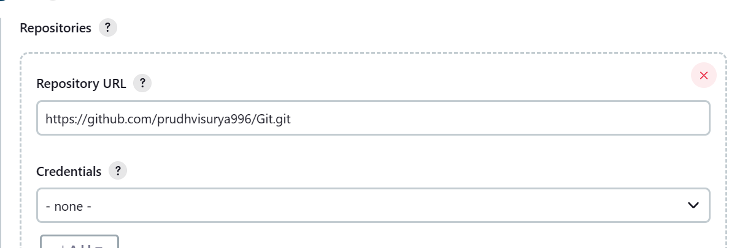

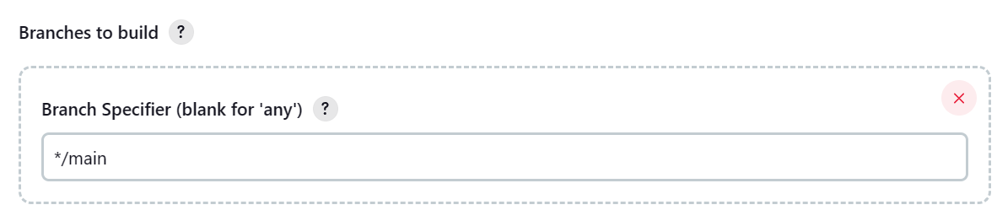

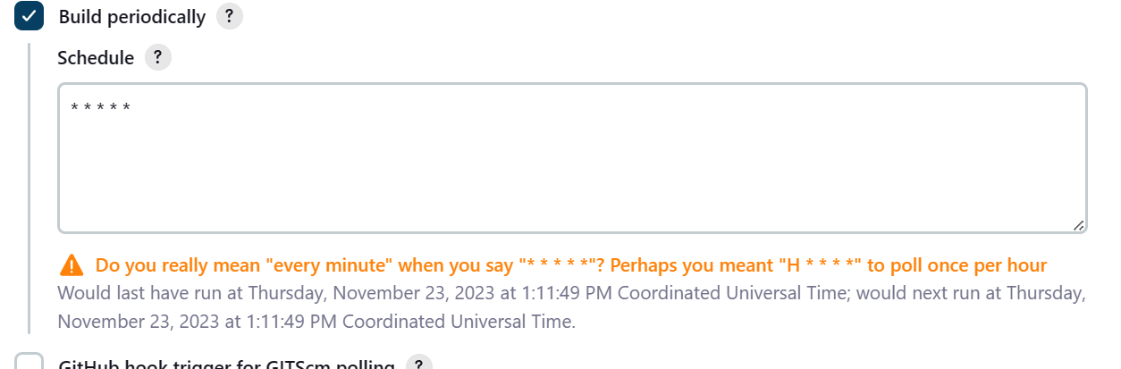

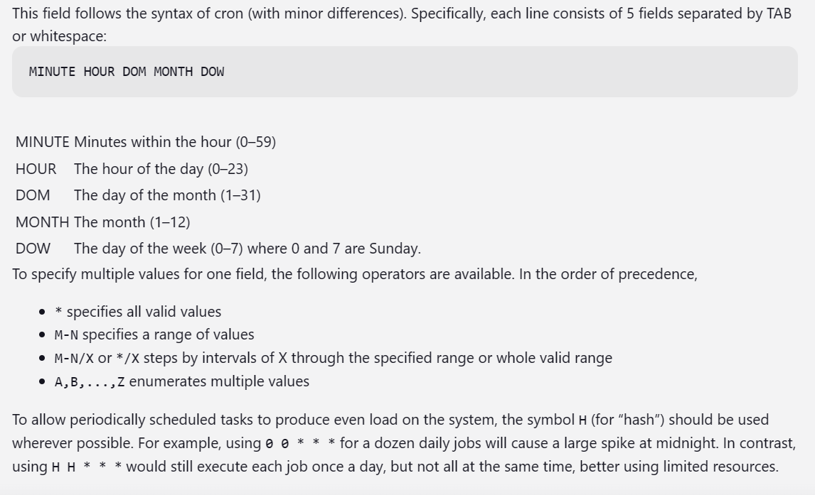

# Every fifteen minutes (perhaps at :07, :22, :37, :52):

H/15 * * * *

# Every ten minutes in the first half of every hour (three times, perhaps at :04, :14, :24):

H(0-29)/10 * * * *

# Once every two hours at 45 minutes past the hour starting at 9:45 AM and finishing at 3:45 PM every weekday:

45 9-16/2 * * 1-5

# Once in every two hour slot between 8 AM and 4 PM every weekday (perhaps at 9:38 AM, 11:38 AM, 1:38 PM, 3:38 PM):

H H(8-15)/2 * * 1-5

# Once a day on the 1st and 15th of every month except December:

H H 1,15 1-11 *

POLLSCM

Git repo used :https://github.com/prudhvisurya996/Jenkins.git

Banch main

POLLSCM : every minute for every change or push

* * * * *

Fo every minute changes are done

Only chnages are done in 0-59 checks for the changes and builds in 60th second

Changed the repo



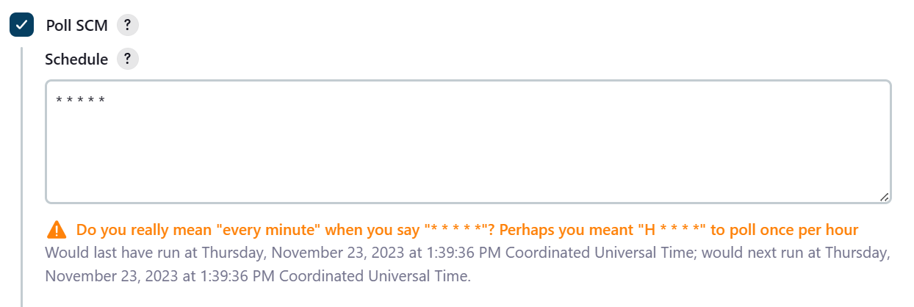

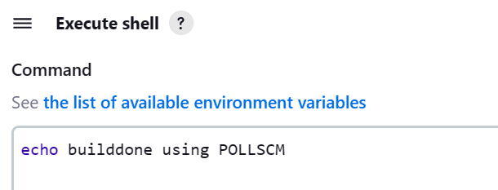



After cloning created this files and pushed to repo

Workspace in jenkins

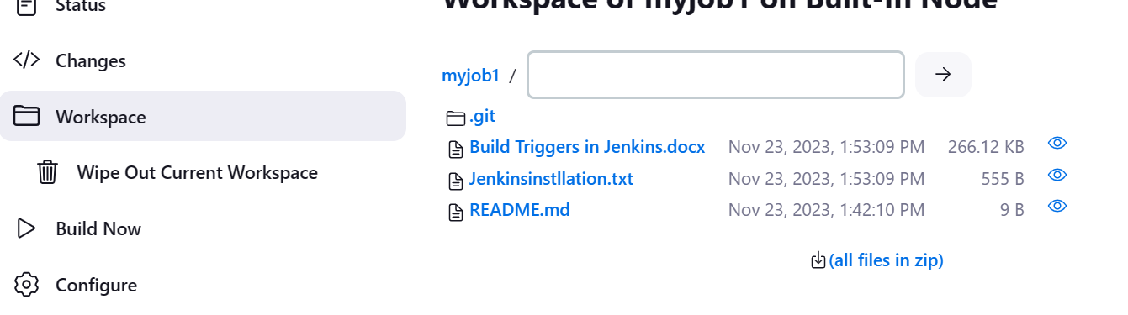

Job got trigerred and this is below output

